Douglas College

ECON1150-005

Principles of Microeconomics

Assignment #2

Student: Dian, Kajol, Dawu

Please note that because there is quite some math in this assignment, many of the questions are in form of picture of and handwritten and typed combined.

Question 1:

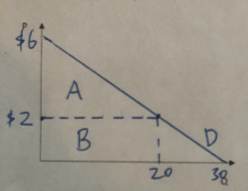

a) At P= $2/cup, Q=30-5x2=20. So I will buy 20 cups per week

b) For the last cup, MV= P = $2. Total value is area A plus area B. So TV=(4x20)/2+(2x20) = 40+40 = $80

c)Total expenditure is area B, TE=2x20= $40. Consumer’s surplus is area A, Surplus = 4x20/2= $40

Question 2:

a) **Preference/taste** has changed, so less haircut is needed because of long hair. Demand curve for haircuts would shift to the **left**, which is a **decrease** in demand.

b) Price of the **substitute goods** has decreased. Demand curve for movies in the theatre would shift to the **left**, which is a **decrease** in demand. Price of rentals goes down leads to quantity of rentals goes up, so quantity of movies goes down.

c)Price of the **complement goods** has increased. Demand curve for snowboards would shift to the **left**, which is a **decrease** in demand. Price of season pass goes up leads to quantity of season pass goes down, so quantity of demand of snowboard goes down as well.

d)**Income** has changed (increased). Demand curve for bus tickets (inferior goods) would shift to the **left**, which is a **decrease** in demand.

e) Future price will decrease, therefore the **relative price of current/future** will go up, the quantity of demand will go down. So, the demand curve for current houses would shift to the **left**, which is a **decrease** in demand.

Question 3: Chapter 5 problem 2:

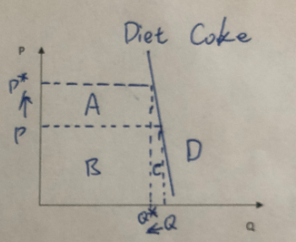

Assume Barbara’s income does not change. Because Barbara's demand for diet coke is inelastic, since the price of coke goes up, the total expenditure for coke will go up as well. We can clearly see this in the graph, that total expenditure before price change is area A+C, and after price increase is area B+C. Area A is clearly larger than C.

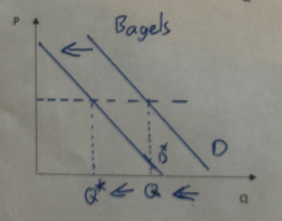

Therefore, her total expenditure for bagels will goes down. With the same price of bagels, the quantity demanded for bagel will decrease. We can see this in the graph as well (demand curve shifts to the left).

Question 4: Chapter 5 problem 6:

True. Mona Lisa is a luxury good, there is only one in this world, and there is no substitute. No matter how the price changes, the demand will stay the same. So, the demand is perfectly inelastic.

Question 5: Chapter 5 problem 8:

a) This make senses. In short run the change of price is not enough for the change of the demand. The price change in BC wood would also change the demand of other woods, and when the price of BC wood increase, the demand of other wood would increase as well. Increase in price for BC wood leads to decrease in quantity of BC wood, therefore the quantity demand of other wood will go up.

b) There will be more wood cut down by other countries. Both supply and demand for other wood will go up, and the price will decrease.

c) Since the “friends of Clayoquot Sound” is now protected from logging, the demand for Amazon forest wood will become higher. That means more wood in Amazon forest will be cut down, which makes it the “enemies” of the Amazon forest.

Question 6: Chapter 5 problem 14:

Q=20-2P

Elasticity at a point: Exx = (change in Q/change in P) x (P/Q)

In this quantity of demand equation, (change in Q/change in P) = -2

|  |  |  |  |
| --- | --- | --- | --- |
| P | Q | Elasticity | Total Revenue = P1 x Q1 |
| 8 | 20-2x8=4 | -2 x (8/2) = -4 | 8x4=32 |
| 7 | 20-2x7=6 | -2 x (7/6) = -2.33 | 7x6=42 |
| 6 | 20-2x6=8 | -2 x (6/8) = -1.5 | 6x8=48 |
| 5 | 20-2x5=10 | -2 x (5/10) = -1 | 5x10=50 |
| 4 | 20-2x4=12 | -2 x (4/12) = -0.67 | 4x12=48 |
| 3 | 20-2x3=14 | -2 x (3/14) = -0.43 | 3x14=42 |

Question 7: Chapter 5 problem 16:

a)

2010: 30 million salmon spawned.

Q2010 = 30 million x 30% = 9 million. P2010 = $1

2009: 1 million salmon spawned.

Q2009 = 1 million x 30% = 0.3 million. P2009 = $5

Arc elasticity equation: E = (change in Q/change in P) x (P bar / Q bar)

change in Q/change in P = (9-0.3)/ (1-5) = -2.175

P bar = (1+5)/2=3

Q bar = (9+0.3)/2 = 4.65

**E = -2.175 x (3/4.65) = -1.4**

b) No. Because the elasticity is greater than 1, which means when price goes up, the total revenue goes down. So, in 2010, the fishermen’s total revenue was actually less than it was in 2009. Increase in fish price leads to decrease in income.

Question 8: Chapter 5 problem 18:

1. This doesn’t make economic sense. Because decrease in price leads to increase for quantity of demand, NOT the demand (the demand curve does not shift).
2. This makes economic sense. “Other things equal” condition has changed here because of the 9/11 attack. Since consumers is more alert to airplane after the attack, the demand will increase here (the demand curve shifts to the left).

Question 9: Chapter 5 problem 20:

Q = 500 - 20P, change in Q / change in P = -20

a) At P­ = 5, Q = 500 – 20x5 = 400.

Point elasticity**: E = -20 x (5/400) = -0.25**

b) At P = 11, Q = 500 – 11x5 = 445.

P bar = (5+11)/2 = 8

Q bar = (400+445)/2 = 422.5

Arc elasticity equation: E = (change in Q/change in P) x (P bar / Q bar)

Arc elasticity: **E = -20 x 8/422.5 = -0.38**

Question 10 (bonus):

A lot of math here, please see picture of hand written below.

